Intro
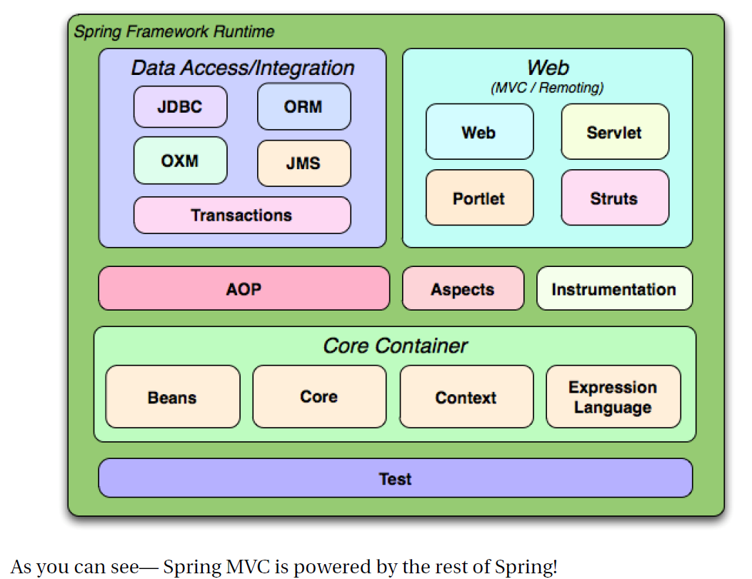
Web - (artifact) spring-web - Core web package for use in any web environment.
Servlet - (artifact) spring-webmvc - Spring MVC support package for use in a Servlet environment. Includes support for common view technologies.

Spring
The Web part. V SF Ref.

Building URIs (par. 17.7 SF-Ref)

Spring MVC
Spring's web framework is designed to help you address state management, workflow, and validation concerns. Based on the Model-View-Controller (MVC) pattern, Spring MVC helps you build web-based applications that are as flexible and as loosely coupled as the Spring Framework itself.
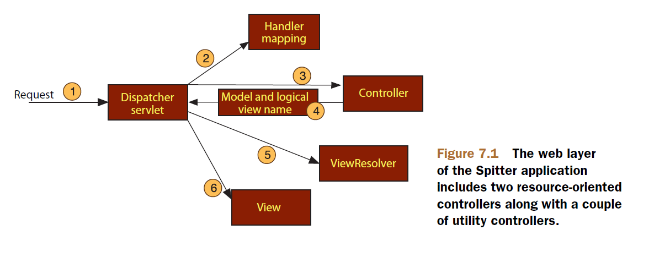

Next figure also explains good spring mvc:

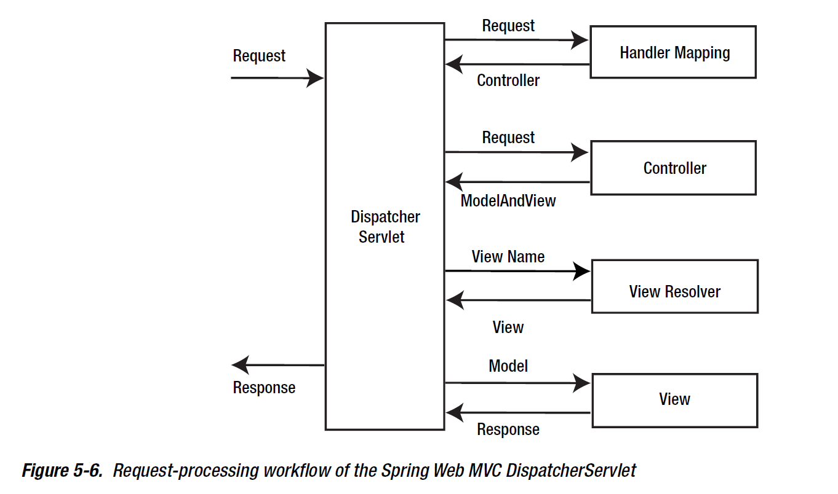

The DispatcherServlet's job is to send the request on to a Spring MVC controller.

Controller
A controller is a Spring component that processes the request.
A typical application may have several controllers and DispatcherServlet needs some help deciding which controller to send the request to. So the DispatcherServlet consults one ore more handler mappings to figure out where the request's next stop will be. Handler mappings precesses URL!!
Once an appropriate controller has been chosen, DispatcherServlet sends the request to the chosen controller. At the controller, the request will drop off its payload (the information submitted by the user) and patiently wait while the contoller processes that information. (Actually, a well-designed controller performs little or no processing itself and instead delegates a responsabiliy for the business logic to one or more service objects.)
… for web application flow continue pag. 165 Spring in action.

Implementing Controllers (chapter 5 Pro Spring MVC)
With Spring MVC, we have two options when writing controllers. We can either implement an interface or put an annotation on the class. The interface is org.springframework.web.servlet.mvc.Controller, and the annotation is org.springframework.stereotype.Controller.
There are two major differences between them.
The first difference is about flexibility, and the second is about mapping URLs to controllers. Annotation-based controllers allow for very flexible method signatures, whereas the interface-based approach has a predefined method on the interface that we must implement.
For the interface-based approach, we must do explicit external mapping of URLs to these controllers so that all the URLs are in a single location.
Spring has a bunch out-of-the-box controllers. But most of those are deprecated in favor of annotation-based approach.

Request-handling method
@RequestMapping
For more informations on @RequestMapping see pag.111 e seguenti Pro Spring MVC...

Supported Method Argument Types
A request-handling method can have various method arguments and return values. For complete table see pag. 114 Pro Spring MVC.

Supported Method Argument Annotations
In addition to explicity supported types, there are also a couple of annotations that we can use to annotate our method arguments. Some of these can also be used with the method argument types. In that case, they are used to specify what the name of the attribute in the request, cookie, header, or response must be, as well as whether the parameter is required.

Supported Method Return Values
…

Form Data-binding
…

Form Tag Library
To be able to use all the data binding features provided by the framework, we also need to use the tag library to write forms.
Spring MVC ships with two tag libraries (general-purpose and form-specific).
Tables for both libraries can be found at pag. 143 e seguenti Pro Spring MVC.
The central tag of form library is <form> that renders an HTML form tag and exposes the binding path to the other form tags inside it.

Resolving and Implementing Views
...

WebApplicationContext
In web applications, the ApplicationContext used is called WebApplicationContext, and it is a specialized ApplicationContext that is aware of the servlet environment. It is the ROOT ApplicationContext in a web application and must be loaded before DispatcherServelt initializes to ensure that all of the services such as the data source are available that are requierd by the web application. WebApplicationContext is configured in the web.xml file using ContextLoaderListener:
<listener>
<listener-class>
org.springframework.web.context.ContextLoaderListener
</listener-class>
</listener>

By default, ContextLoaderListener loads the application context file stored in your WEB-INF directory. This location can be overridden by defining the contextConfigLocation context parameter in web.xml:
<context-param>
<param-name>contextConfigLocation</param-name>
<param-value>
classpath:service-context.xml
classpath:data-access-context.xml
</param-value>
</context-param>

DispatcherServlet, like any other servlet, is declared in the web.xml file of your web application. You need to map requests that you want DispatcherServlet to handle, by using a URL mapping in the same web.xml file:
<web-app>
<servlet>
<servlet-name>bookstore</servlet-name>
<servlet-class>org.springframework.web.servlet.DispatcherServlet</servlet-class>
<load-on-startup>1</load-on-startup>
</servlet>
<servlet-mapping>
<servlet-name>bookstore</servlet-name>
<url-pattern>/bookstore/*</url-pattern>
</servlet-mapping>
</web-app>

In a Servlet 3.0 and newer environment, you can also use WebApplicationInitilizer, an inteface provided by the Spring MVC framework, to configure the servlet container programmatically:

public class ExampleWebApplicationInitializer implements WebApplicationInitializer {
@Override
public void onStartup(ServletContext container) {
ServletRegistration.Dynamic registration = container.addServlet("dispatcher",
new DispatcherServlet());
registration.setLoadOnStartup(1);
registration.addMapping("/bookstore/*");
}
}

